Deploying Deep Learning Burned-Area Detection Models on Sentinel-2 Imagery: A Case Study Comparing Swin-YNet and EfficientNet-B2 in Northeastern Portugal

INTRODUCTION

Forest fires are among Portugal's most serious environmental and social issues each year. Every summer, large parts of the country experience fires, resulting in loss of life, destruction of homes and livelihoods, and damage to forests and woodlands. For instance, the June 2017 Pedrógão Grande fire killed 64 people, injured about 250, burned over 46,000 hectares in five days, and caused damage estimated at 200 million euros (Mayers, 2024). This event remains one of the most destructive recent fires. Portugal's vulnerability stems from a combination of climatic and land factors: hot, dry summers make the landscape prone to burning, and climatic conditions explain about 56% of the annual variation in burned areas (DaCamara, 2024). Years of rural abandonment have led to fuel buildup, and dense stands of fast-growing, highly flammable pine and eucalyptus trees enable fires to spread rapidly, with shrublands igniting under normal summer conditions and forests burning under extreme fire weather (Calheiros et al., 2022). Knowing the precise location and extent of a fire quickly influences many subsequent decisions. Remote sensing has become essential because it provides rapid, reliable assessments of burned areas, enabling prompt post-fire assessment (Llorens et al., 2021). Accurate burned area maps are crucial for guiding aerial firefighting, emergency logistics, and initiating legal and insurance processes.

The main objective of this study is to deploy and scale burned-area detection models to tile-wide inference, enabling the production of a continuous, georeferenced burned-area map for an entire Sentinel-2 scene. Specifically, it aims to:
- Build an inference pipeline that converts the model's per-chip predictions into a single georeferenced burned-area map of the full Sentinel-2 T29TPG tile,
- Tune the overlap aggregation scheme and a minimum-size filter to produce a seamless map free of small, scattered detections,
- Compare the two fine-tuned models (MSR-BACD and EfficientNet-B2) against the ICNF fire records, including their runtime and memory costs, and recommend a practical deployment setting, and
- Deliver a minimum viable web application that runs a chosen configuration and displays the resulting burned-area map on an interactive viewer.
DATA

Study Area and Data Used

The study area focuses on Portugal’s territory within the extent of Sentinel-2 Tile T29TPG in northeastern Portugal. The tile straddles the Portugal-Spain border and the study area corresponds to the Trás-os-Montes region in the districts of Bragança and Vila Real, a fire-prone landscape of shrubland, pine and oak forest stands, and agricultural areas, as shown in Figure 1.
Figure 1
Study area: Sentinel-2 tile T29TPG Extent in Northeastern Portugal
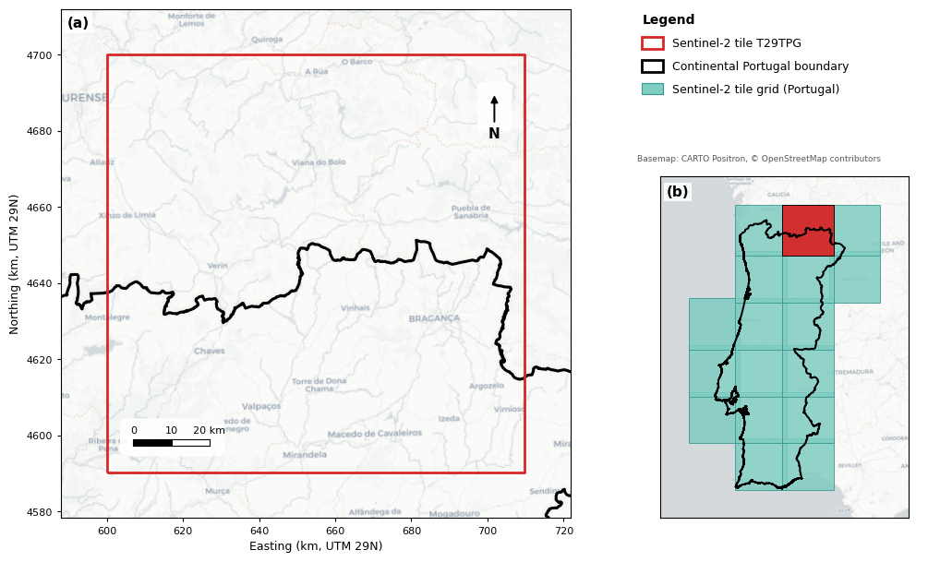
Note. The study area corresponds to Sentinel-2 tile T29TPG (red outline) in northeastern Portugal, shown in panel (a) with the continental Portugal boundary in black and in panel (b) relative to the Sentinel-2 tile grid covering the country; the analysis includes only the Portuguese territory within the tile. Basemap: CARTO Positron, © OpenStreetMap contributors.
The project utilizes two existing datasets: Sentinel-2 imagery for northeastern Portugal in 2025 and ICNF’s official burned-area records for that year. Sentinel-2 images serve as input to the model, while ICNF data provide fire perimeters for validation and event dates to select pre- and post-fire scenes. The input is a Sentinel-2 data cube for 2025, stored in a single HDF5 file, with the main array shaped (79, 10, 622,849,024), representing timestamp, bands, and pixels. This data cube includes 79 scenes acquired throughout 2025, roughly one every five days, each with ten spectral bands covering visible, red-edge, and near-infrared regions at 10-meter resolution. Values are uint16 surface reflectance ranging from 0 to 10000, with NoData encoded as 65535. The array is chunked into shapes of (12, 10, 65,536), representing a 256 by 256 pixel chip with ten bands for 12 sequential scenes.

The reference data comprises the ICNF’s official burned-area records for mainland Portugal in 2025 within the study area. Each fire in the shapefile includes the fire code, start and end dates and times, duration, district, municipality, parish, cause class, and burned area in hectares, categorized as forest, shrubland, or farmland. After masking the ICNF data to the study area, 182 fire events fall within the tile, including 15 exceeding 65 ha (Figure 2).

Figure 2

Data Cleaning and Transformation
DATA ORGANIZATION

Training and Validation

The two deep learning models in this study were developed independently and were not based on T29TPG. They were trained and tested using the VChips created under DGT/ISA contract 3044-D (Jesús Céspedes, 2026). These VChips include 179 visual change-detection chips, each measuring 4 km by 4 km, with manual interpretation of before/after image pairs digitized in QGIS. They are categorized into five change classes (values 0 to 4) along with a separate NoData value (255). The chips cover five fire seasons: 24 from 2019, 81 from 2020, 26 from 2021, 37 from 2022, and 11 from 2023. An additional 42 VChips, taken outside the DGT potential-vegetation-loss mask, are labeled "no change" to help the models learn that normal changes in agriculture, montado, and urban areas do not indicate vegetation loss. Each chip includes its ten Sentinel-2 bands, ordered from B12 (longest wavelength) to B2 (shortest), plus a date band, which are reversed to the standard B2 to B12 order before training to match the prediction pipeline. For this study, the only class of concern is the burned areas (value 4), so every model output is reduced to a binary mask in which the fire class is treated as burned and all other classes as not burned.

Deployment Test Set

The test set includes all evaluable chips within tile T29TPG, assessed against ICNF reference data as a measure of model accuracy (Chuvieco et al., 2019). There is no overlap between the 2025 evaluation and 2019–2023 VChip years. Ground-truth labels are derived from ICNF ardida_2025 polygons, rasterized onto the 10 m chip grid in the tile CRS (EPSG:32629), and eroded inward by one pixel to remove ambiguous burn-perimeter pixels, which could otherwise inflate error (Stehman & Foody, 2019). Chips the pipeline could not observe are excluded from scoring. The evaluation uses a single shared before/after image pair across the entire tile, with a baseline date of 2025-07-07 and a subsequent scene of 2025-10-15, both clear and with 1% cloud cover.

METHODS
RESULTS
ANALYSIS
DEPLOYMENT
REFERENCES

Calheiros, T., Benali, A., Pereira, M., Silva, J., & Nunes, J. (2022). Drivers of extreme burnt area in Portugal: Fire weather and vegetation. Natural Hazards and Earth System Sciences, 22, 4019–4037. https://doi.org/10.5194/nhess-22-4019-2022

DaCamara, C. C. (2024). The signature of climate in annual burned area in Portugal. Climate, 12 (9), 143. https://doi.org/10.3390/cli12090143

Mayers, L. (2024). The open wounds of Pedrógão Grande. Wildfire Magazine, International Association of Wildland Fire. https://www.iawfonline.org/article/the-open-wounds-of-pedrogao-grande/

CARTO. (n.d.). Positron basemap [Basemap]. https://carto.com/attributions

European Space Agency. (2025). Sentinel-2 MSI Level-2A surface reflectance [Data set]. Copernicus Data Space Ecosystem. https://dataspace.copernicus.eu/

Instituto da Conservação da Natureza e das Florestas. (2026). Áreas ardidas 2025 [Data set]. https://si.icnf.pt/wfs/areas_ardidas

OpenStreetMap contributors. (2026). OpenStreetMap [Basemap]. https://www.openstreetmap.org/

Raschka, S., Liu, Y., & Mirjalili, V. (2022). Machine learning with PyTorch and scikit-learn: Develop machine learning and deep learning models with Python. Packt Publishing.

CONTRIBUTIONS

